Task 1: Create an S3 bucket and upload objects
Step 1: Login to AWS Console
- Open: https://console.aws.amazon.com
- Search: S3
- Click Create bucket
Step 2: Configure bucket
- Bucket name: my-static-site-12345 (must be globally unique)
- Region: ap-south-1 (Mumbai) (recommended near users)
- Keep defaults
- Click Create bucket
Step 3: Upload files
- Open bucket
- Click Upload
- Click Add files
- Select files (example: index.html, image.png)
- Click Upload
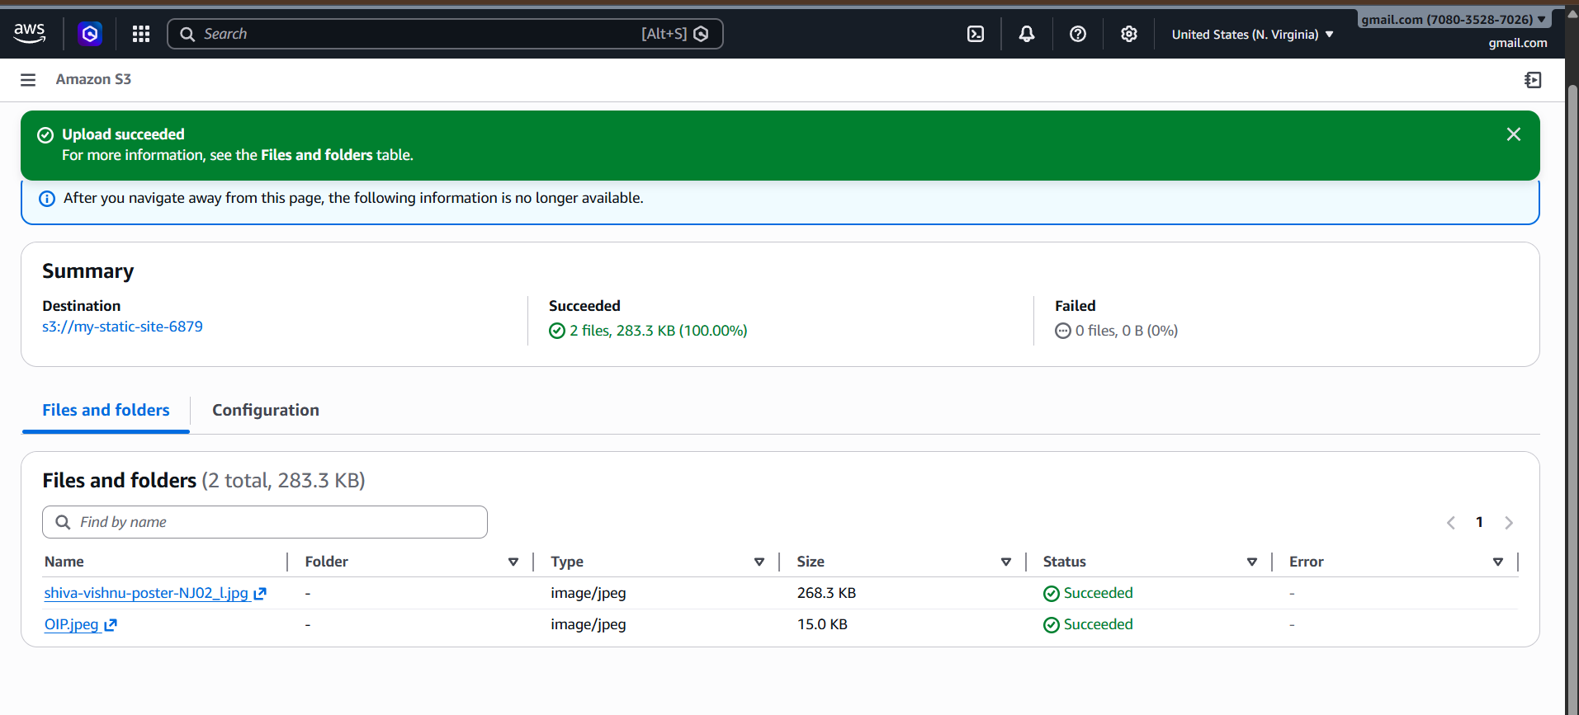
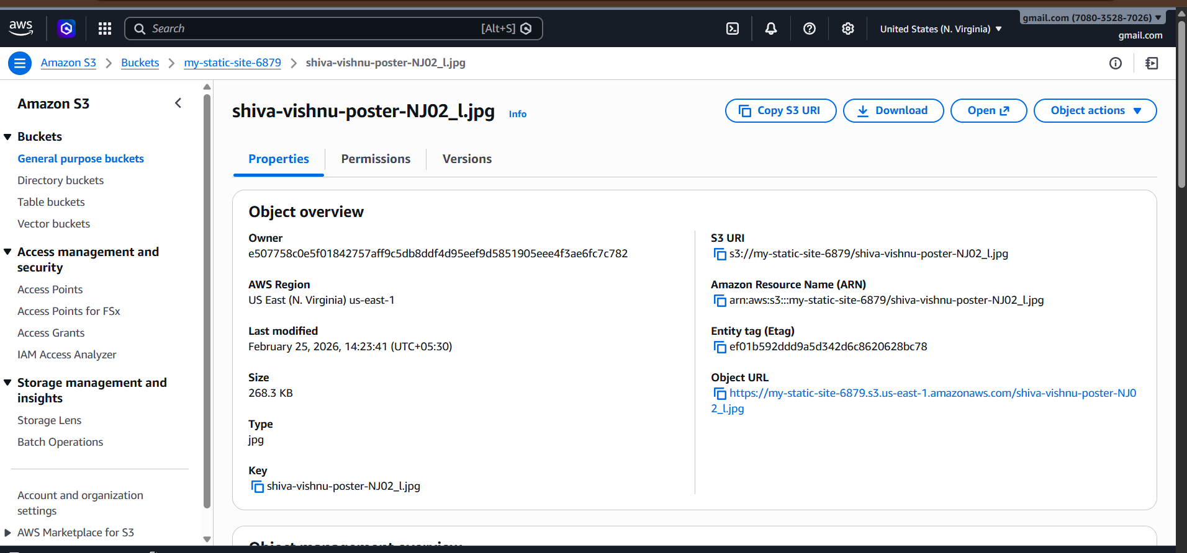
Objects successfully uploaded

Task 2: Deploy static website in S3 bucket
Step 1: Enable static website hosting
- Go to S3 → Your bucket
- Click Properties
- Scroll → Static website hosting
- Click Edit
- Enable → Static website hosting
Enter:
Index document: index.html
Error document: error.html
Save
Step 3: Add bucket policy
Go to:
Permissions → Bucket policy → Paste:
{
"Version": "2012-10-17",
"Statement": [
{
"Sid": "PublicRead",
"Effect": "Allow",
"Principal": "*",
"Action": "s3:GetObject",
"Resource": "arn:aws:s3:::my-static-site-12345/*"
}
]
}

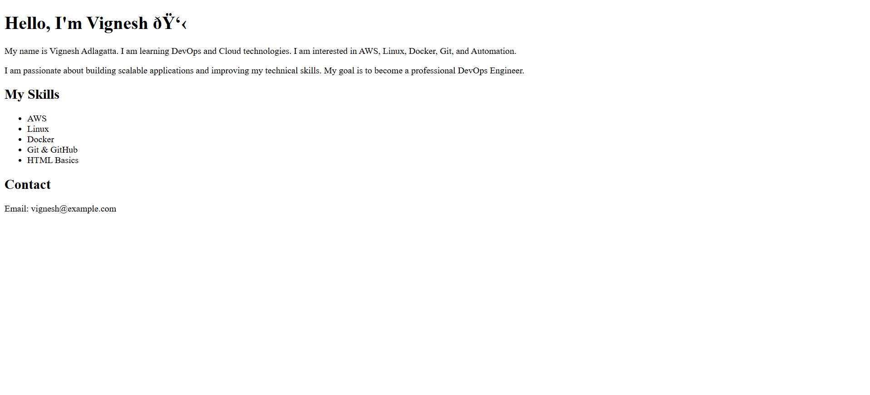
Step 4: Access website
Go to:
Properties → Static website hosting
You will get URL:
http://my-static-site-6879.s3-website-us-east-1.amazonaws.com/
Website is live

Task 3: Enable Cross-Region Replication (CRR)
Step 1: Create destination bucket
Example:
my-static-site-replica
Region: us-east-1

Step 2: Enable versioning on both buckets
Source bucket:
Properties → Versioning → Enable
Destination bucket:
Properties → Versioning → Enable
Step 3: Create replication rule
Source bucket → Management → Replication → Create rule
Enter:
Rule name:
replication-rule
Destination bucket:
vpc-flowlogs-bucket-12345
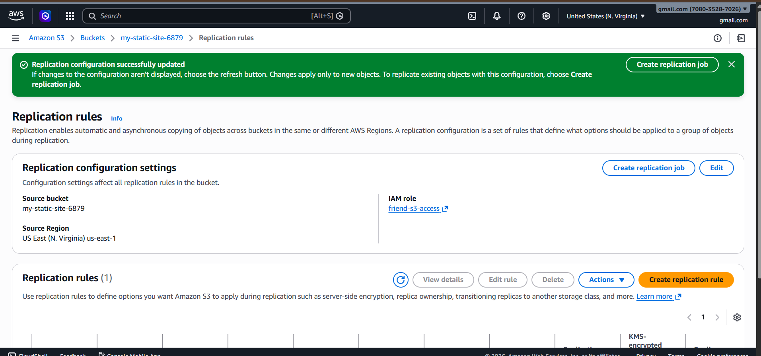
Create IAM role automatically
Save 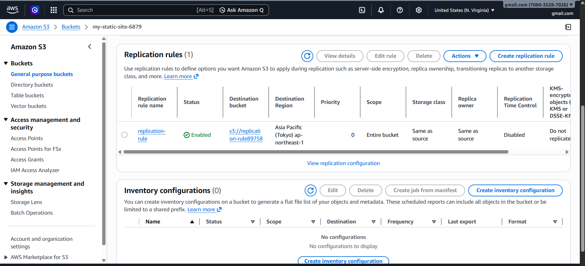
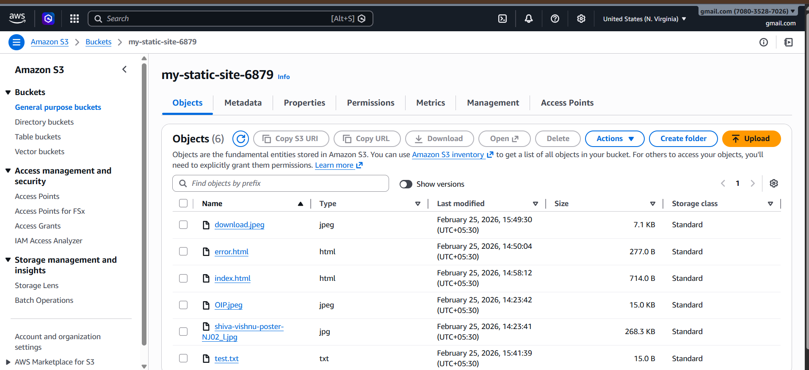

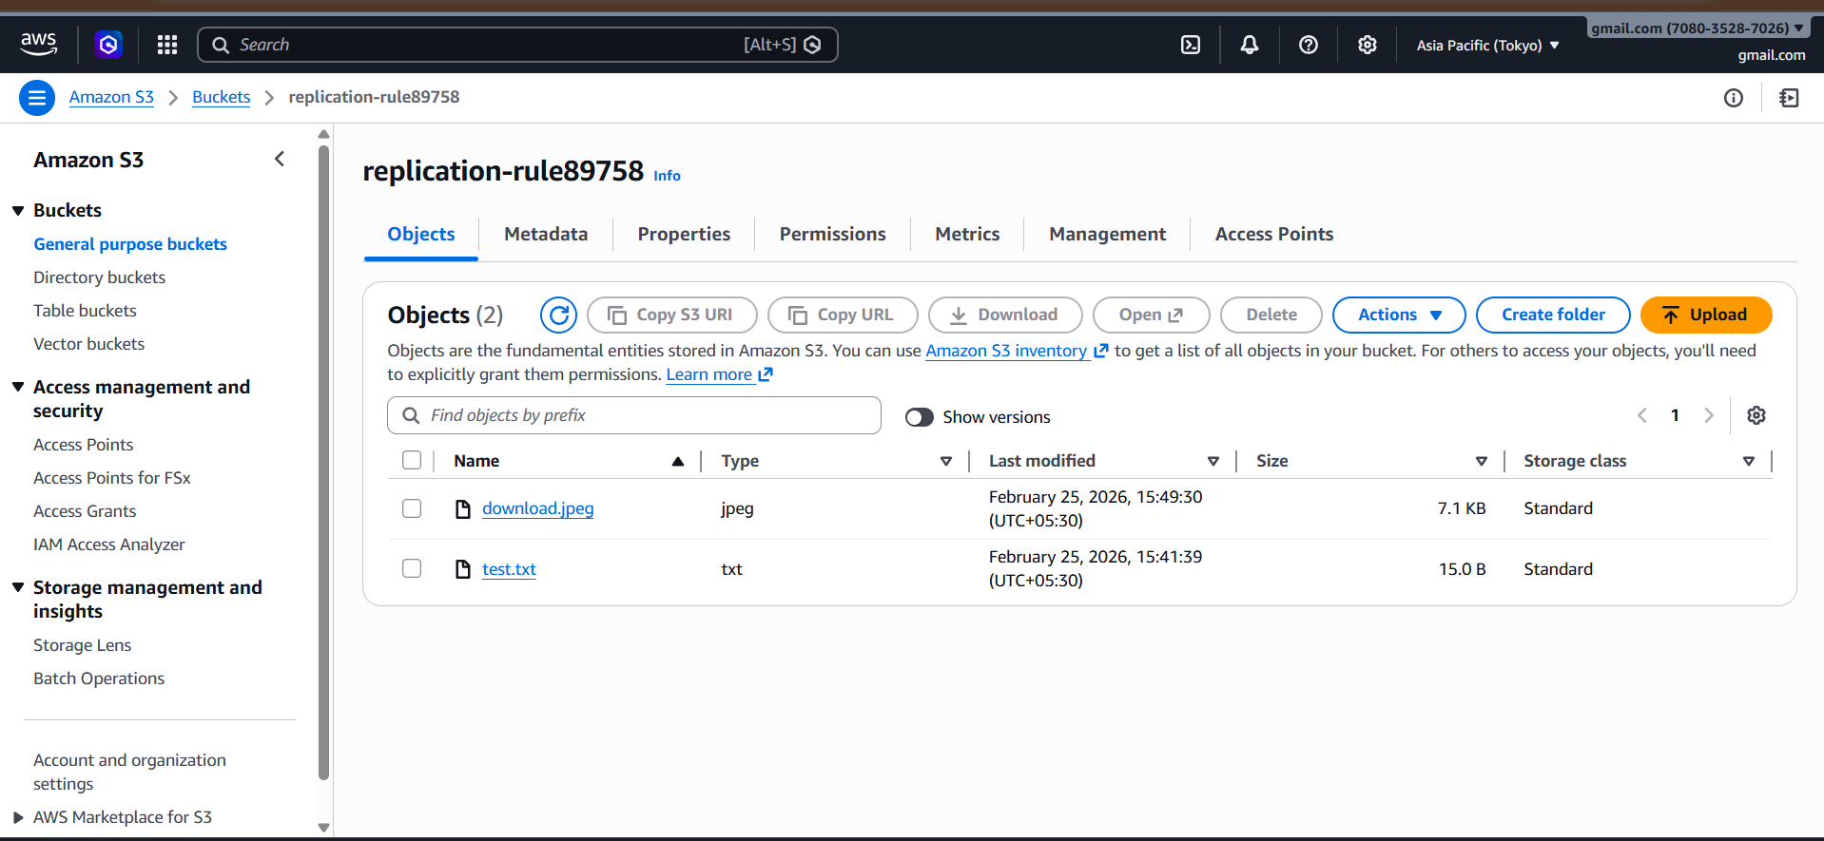
Now upload file → automatically replicated to other region

Task 4: Bucket policy so only Admin user can access
Architecture Overview
AWS Account
├── S3 Bucket: my-static-site-6879
├── IAM User: Admin (Allowed)
└── IAM User: TestUser (Denied)
Step 1: Create S3 Bucket
1. Login to AWS Console
2. Open S3 service
3. Click Create bucket
4. Enter bucket name: my-static-site-6879
5. Select region: ap-south-1
6. Disable Block Public Access (if needed)
7. Click Create bucket

Step 2: Create Admin User
1. Open IAM service
2. Click Users → Create user
3. Enter name: Admin
4. Enable console access
5. Attach policy: AmazonS3FullAccess
6. Create user and save credentials

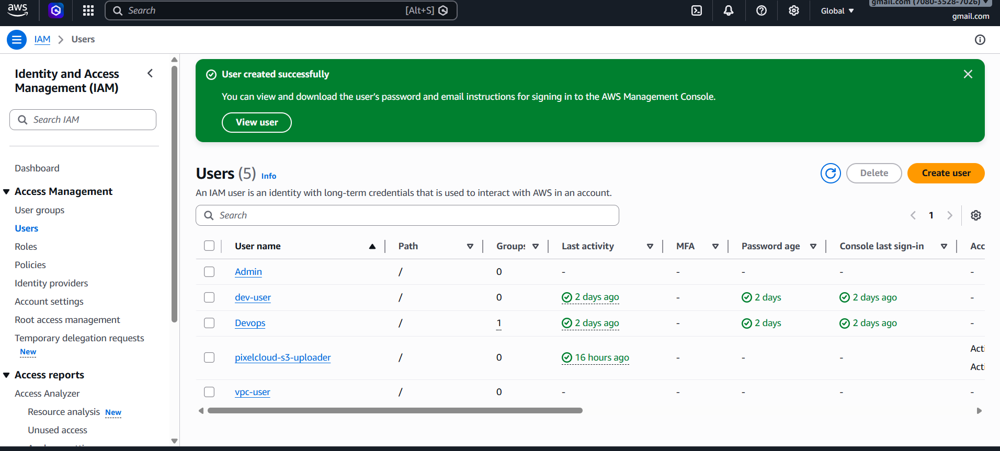

Step 3: Create TestUser
1. Go to IAM → Users → Create user
2. Enter name: TestUser
3. Enable console access
4. Attach policy: AmazonS3FullAccess
5. Create user

Step 4: Apply Bucket Policy
Go to S3 → Bucket → Permissions → Bucket Policy and paste:
{
"Version": "2012-10-17",
"Statement": [
{
"Sid": "AllowAdminFullAccess",
"Effect": "Allow",
"Principal": {
"AWS": "arn:aws:iam::708035287026:user/Admin"
},
"Action": "s3:*",
"Resource": [
"arn:aws:s3:::my-static-site-6879",
"arn:aws:s3:::my-static-site-6879/*"
]
},
{
"Sid": "DenyAllExceptAdmin",
"Effect": "Deny",
"NotPrincipal": {
"AWS": "arn:aws:iam::708035287026:user/Admin"
},
"Action": "s3:*",
"Resource": [
"arn:aws:s3:::my-static-site-6879",
"arn:aws:s3:::my-static-site-6879/*"
]
}
]
}

Step 5: Test Access
Login as Admin → Access allowed

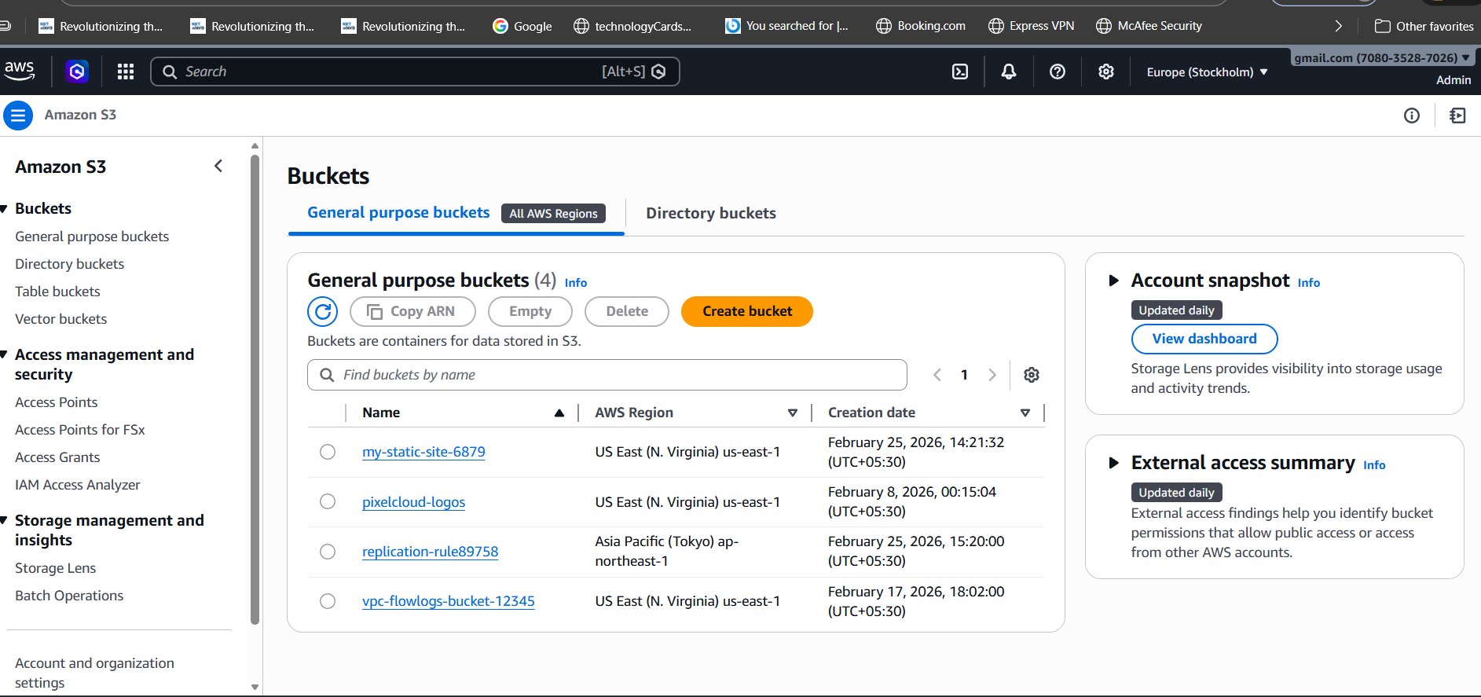
Login as TestUser → Access denied
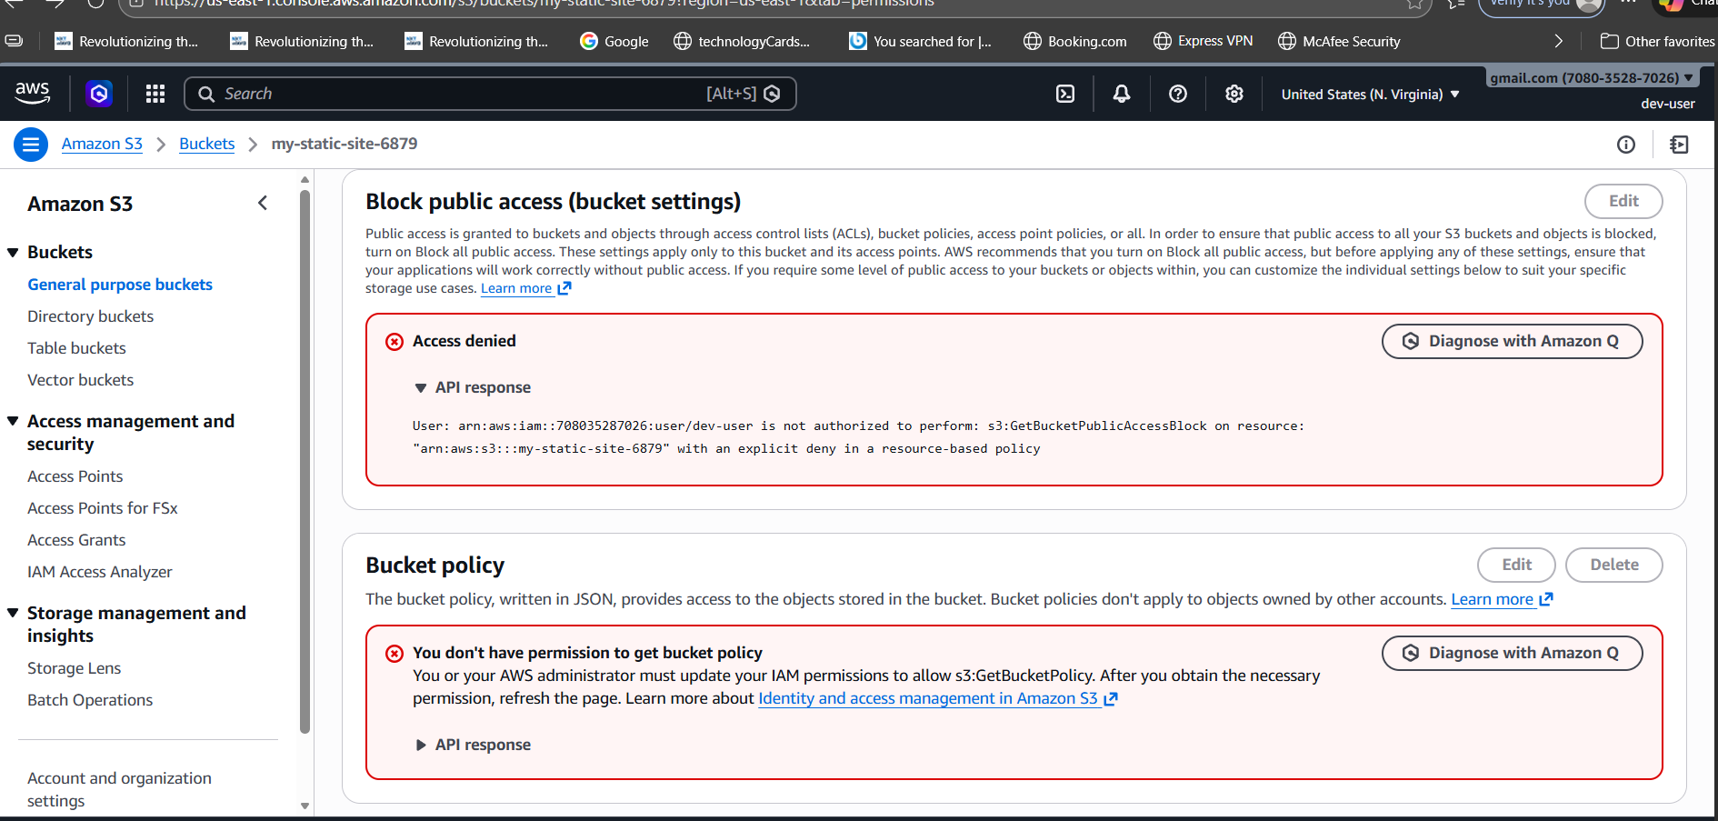

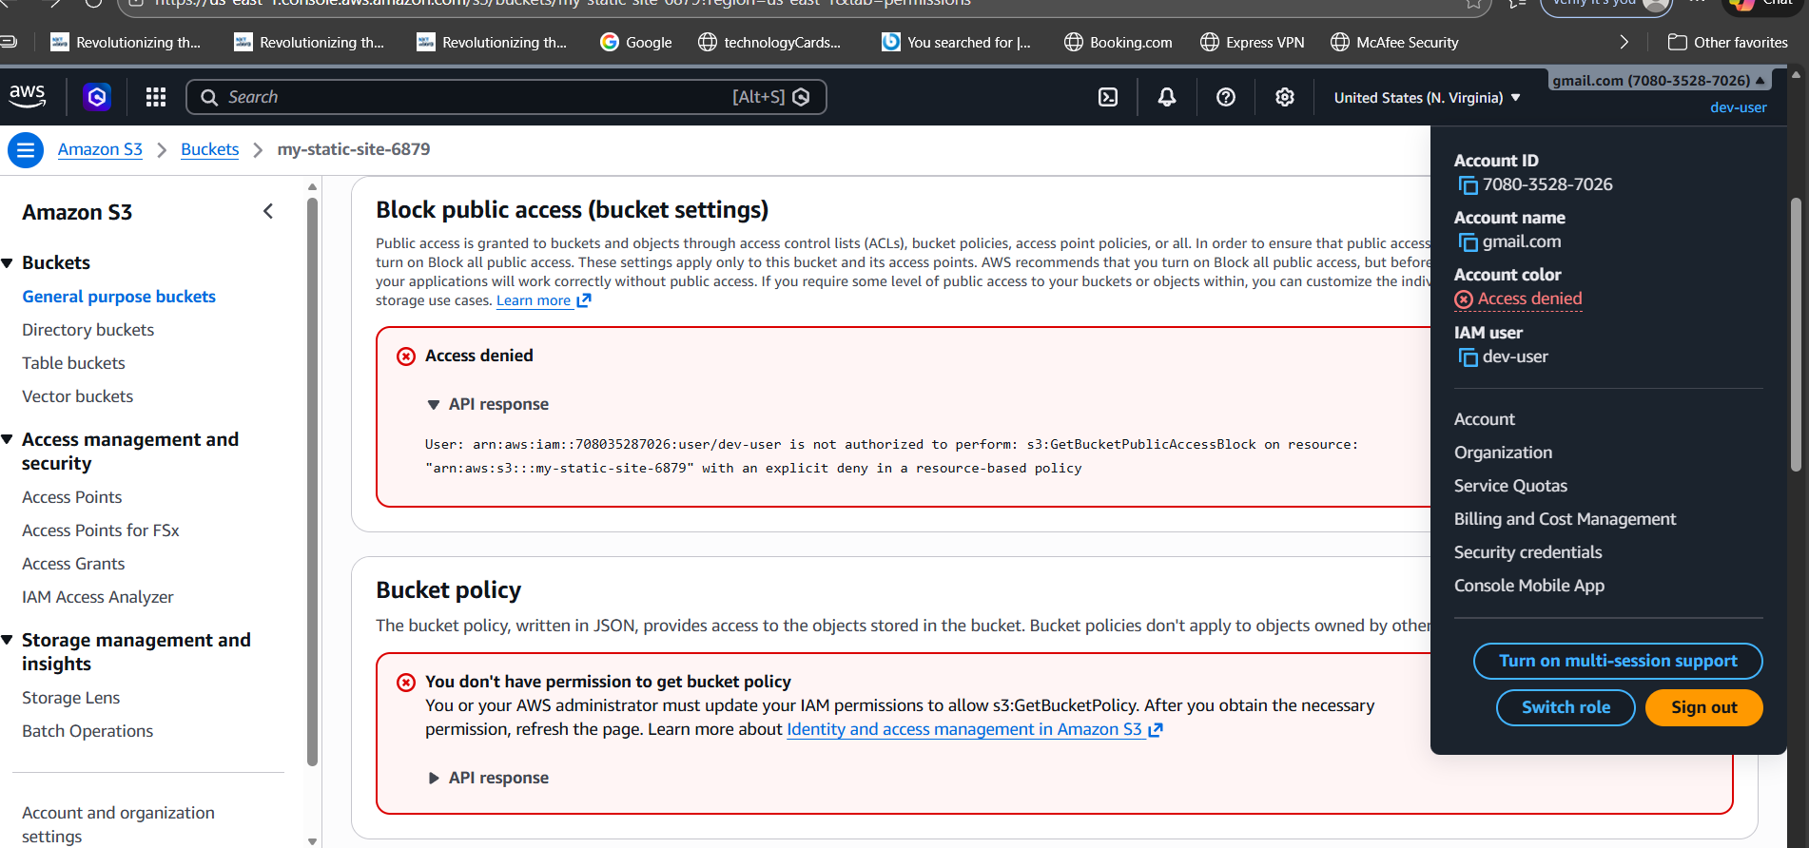

5) Set up lifecycle policies to automatically transition or delete objects based on specific criteria
Step 1: Open S3 bucket
Go to:
AWS Console → S3 → Buckets
Click your bucket:
my-static-site-6879
Step 2: Go to Management tab
Click:
Management
You will see:
Lifecycle rules
Click:
Create lifecycle rule
Step 3: Enter rule name
Example:
Rule name: lifecycle-rule-1
Click:
Next
Step 4: Choose scope
Select:
Apply to all objects in the bucket
Click:
Next
Step 5: Configure Transition (move to cheaper storage)
Click:
Add transition
Select:
Transition to Glacier Flexible Retrieval
Enter:
Days after object creation: 30
This means:
After 30 days → move to Glacier
Click:
Next
After 30 days → move to Glacier
Click:
Next
Step 6: Configure Expiration (delete objects)
Click:
Expire current versions of objects
Enter:
Days after object creation: 365
This means:
After 365 days → delete object
Click:
Next

Step 7: Review and create
Review settings
Click:
Create rule
Lifecycle policy created

How to verify lifecycle policy
Go to:
S3 → my-static-site-6879 → Management → Lifecycle rules
You will see:
lifecycle-rule-1 → Enabled
Day 0 → Upload file
Day 30 → Move to Glacier
Day 365 → Delete file
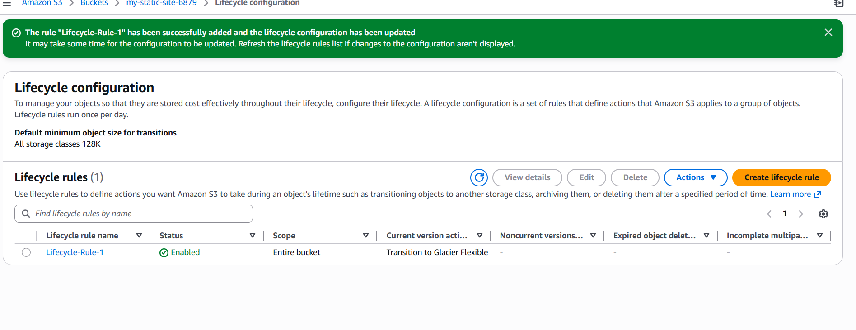
Task 6: Push objects to S3 using AWS CLI
Step 1: Install AWS CLI (if not installed)
Check:
aws --version
If not installed (Ubuntu/Linux):
sudo apt update
sudo apt install awscli -y

Step 2: Configure AWS CLI
Run:
aws configure
Enter:
AWS Access Key ID: (paste your access key)
AWS Secret Access Key: (paste secret key)
Default region name: us-east-1
Default output format: json
You will see:
Configuration saved

Step 3: Upload file to S3
Syntax:
aws s3 cp filename s3://bucket-name/
Example:
aws s3 cp index.html s3://my-static-site-6879/

Step 4: Verify upload
Run:
aws s3 ls s3://my-static-site-6879
Output:
index.html
Upload successful
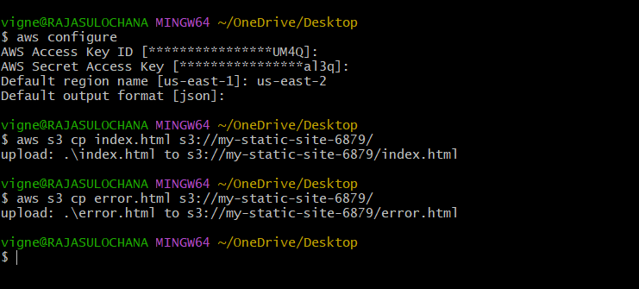

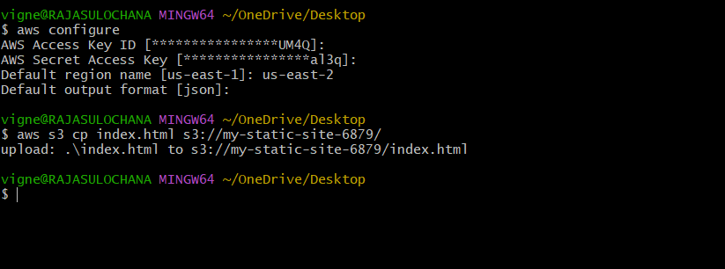
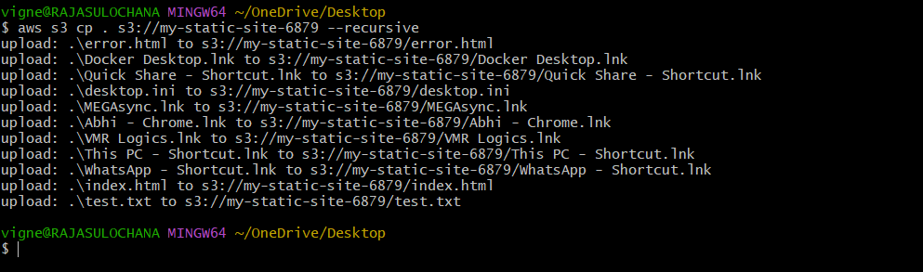

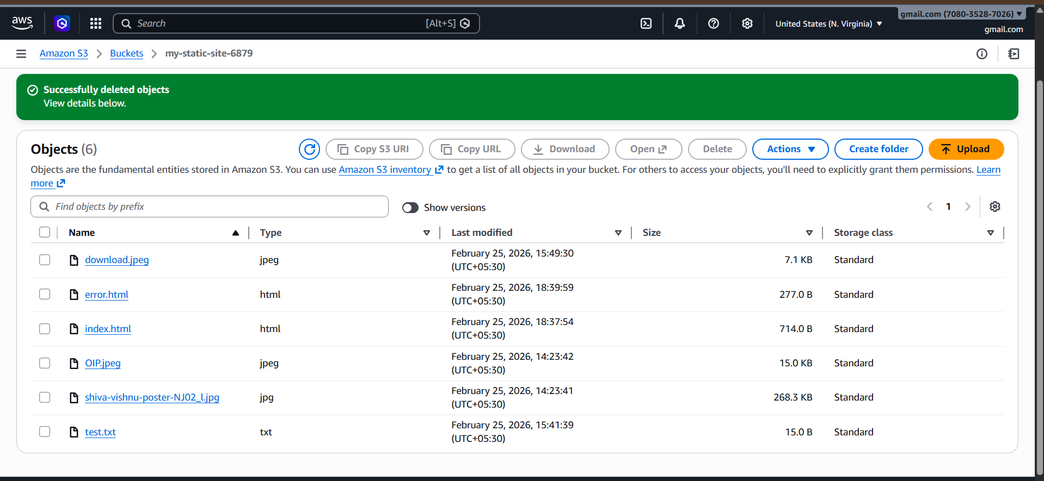
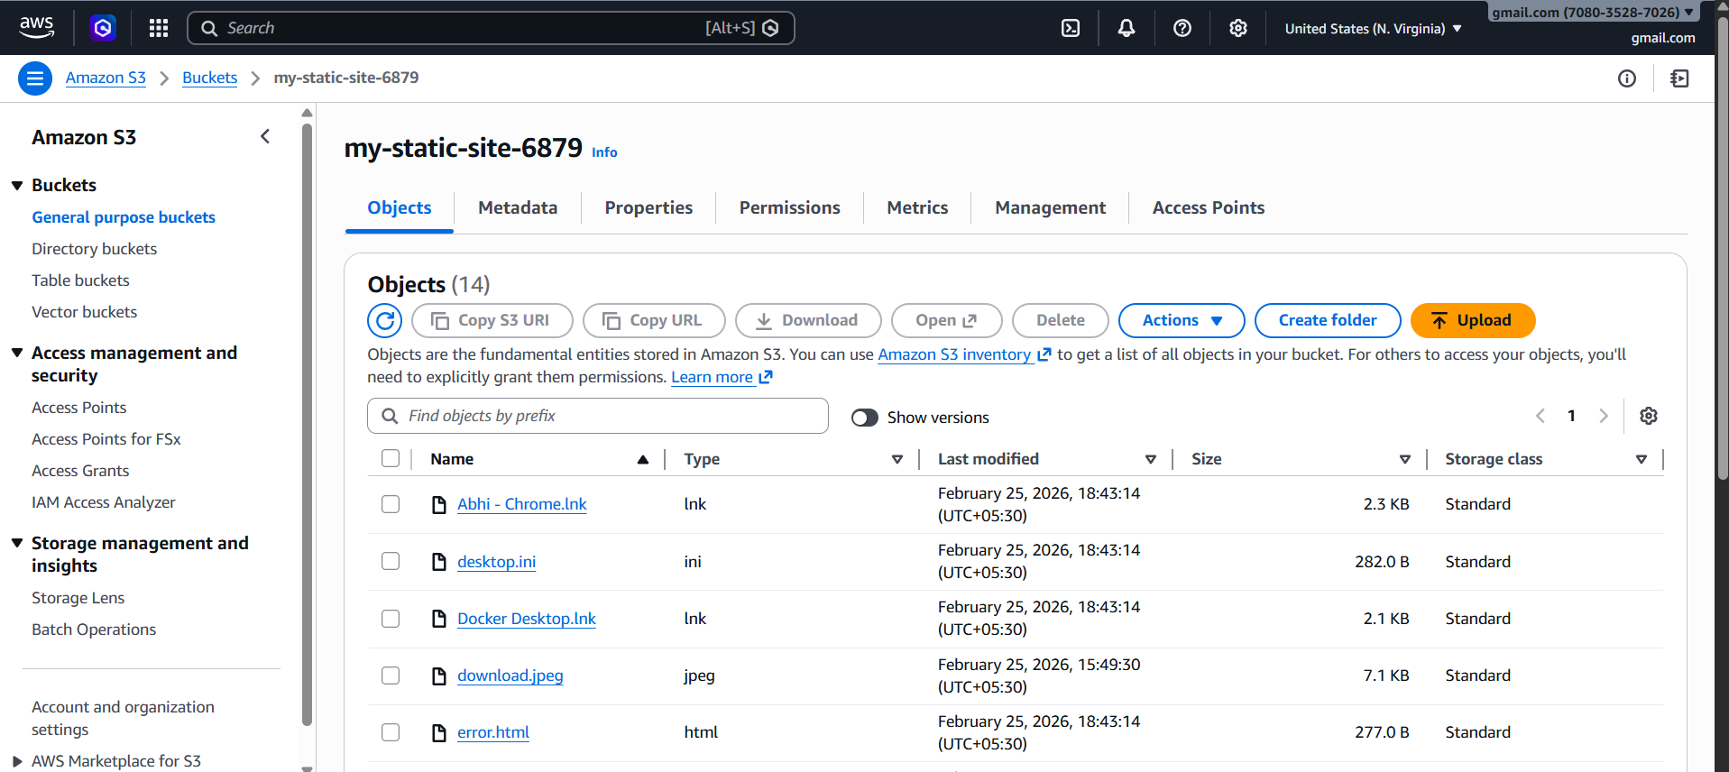

Task 7: Write Bash script to create S3 bucket

Step 1: Create script file
nano create-bucket.sh

Step 2: Paste this script
#!/bin/bash
BUCKET_NAME=my-bash-bucket-6879
REGION=us-east-1
aws s3api create-bucket \
--bucket $BUCKET_NAME \
--region $REGION
echo "Bucket created successfully: $BUCKET_NAME"
Save:
CTRL + C
CTRL + X
Enter

Step 3: Give execute permission
chmod +x create-bucket.sh

Step 4: Run script
./create-bucket.sh
Output:
Bucket created successfully: my-bash-bucket-6879
Verify:
aws s3 ls
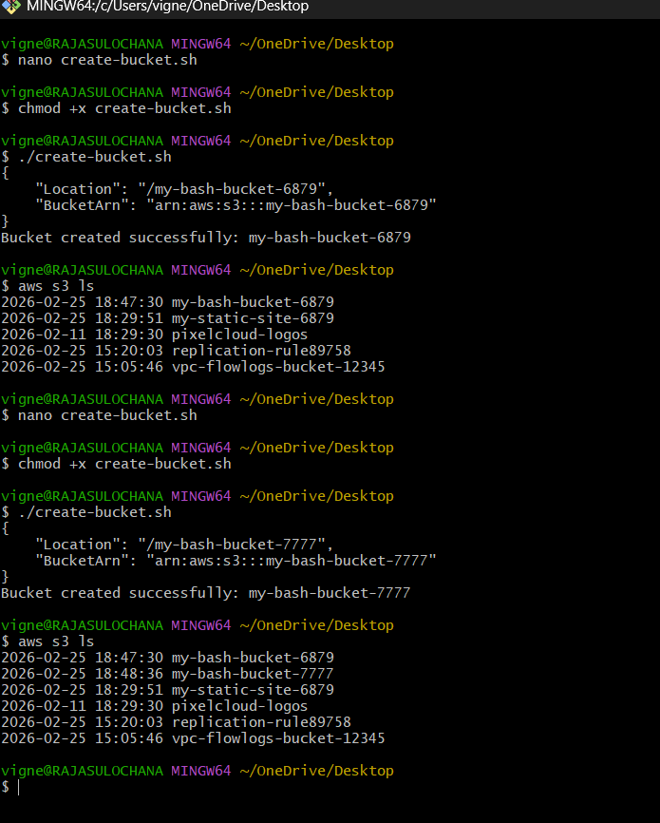
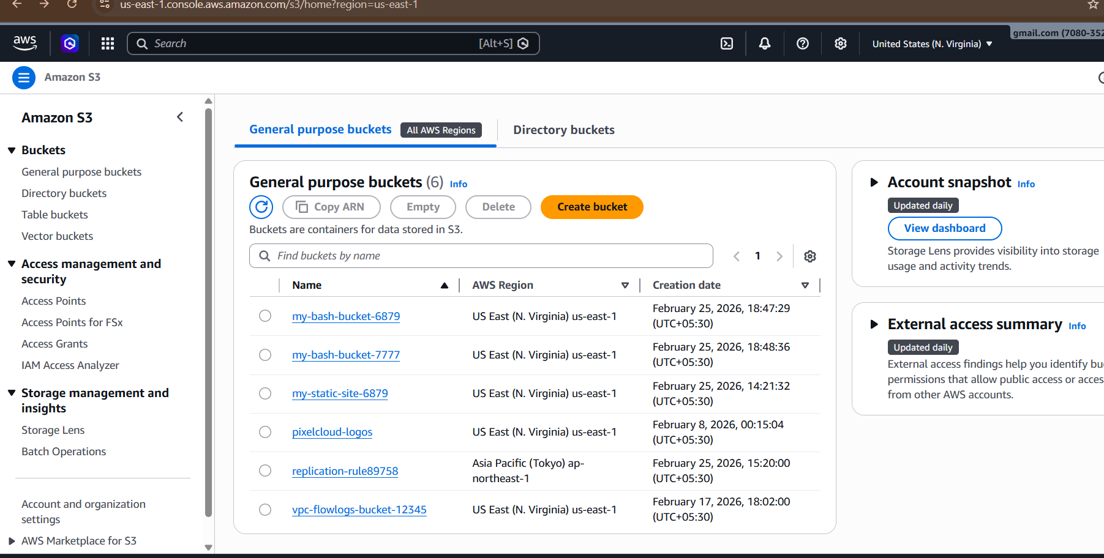

Task 8: Upload 1GB file to S3 using CLI
Step 1: Create 1GB test file
Linux:
dd if=/dev/zero of=1GBfile bs=1M count=1024
This creates:
1GBfile

Step 2: Upload 1GB file
aws s3 cp 1GBfile s3://my-static-site-6879/
AWS will automatically use:
Multipart upload

Step 3: Verify upload
aws s3 ls s3://my-static-site-6879
Output:
1GBfile
Upload successful
